F Y B Tech SEM I 2021-22

Engineering Physics Lab Course

**Experiment No.:**

**Title:NEWTON’S RING**

**Name: Eshan Kalp Trivedi**

**Roll No: 16010221038**

**Branch: Electronics**

**Batch: D2**

**Aim:** To revise the concept of interference of light waves in general and thin-film interference in particular.

To set up and observe Newton’s rings.

To determine the wavelength of the given source.

**Apparatus:**  Light source, Microscope, Lens, Sodium and Glass plate **Diagram:**

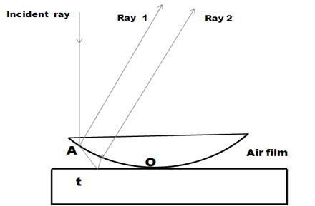

**Observation Table:**

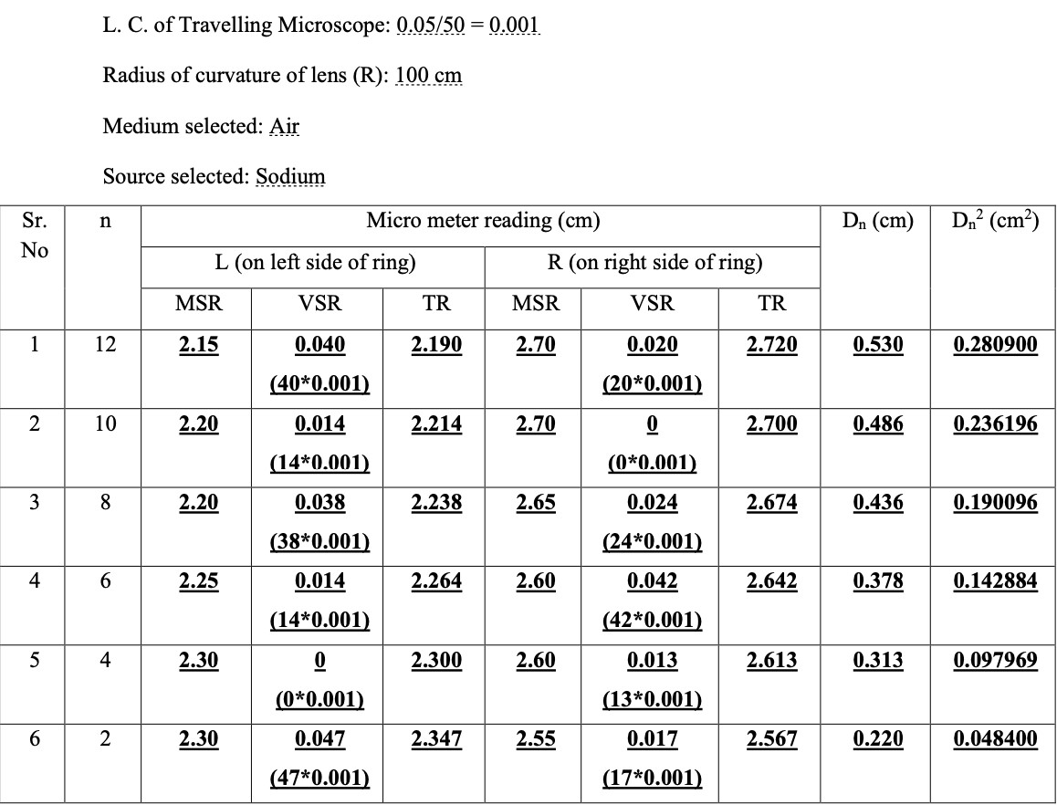

**Graphs*:**

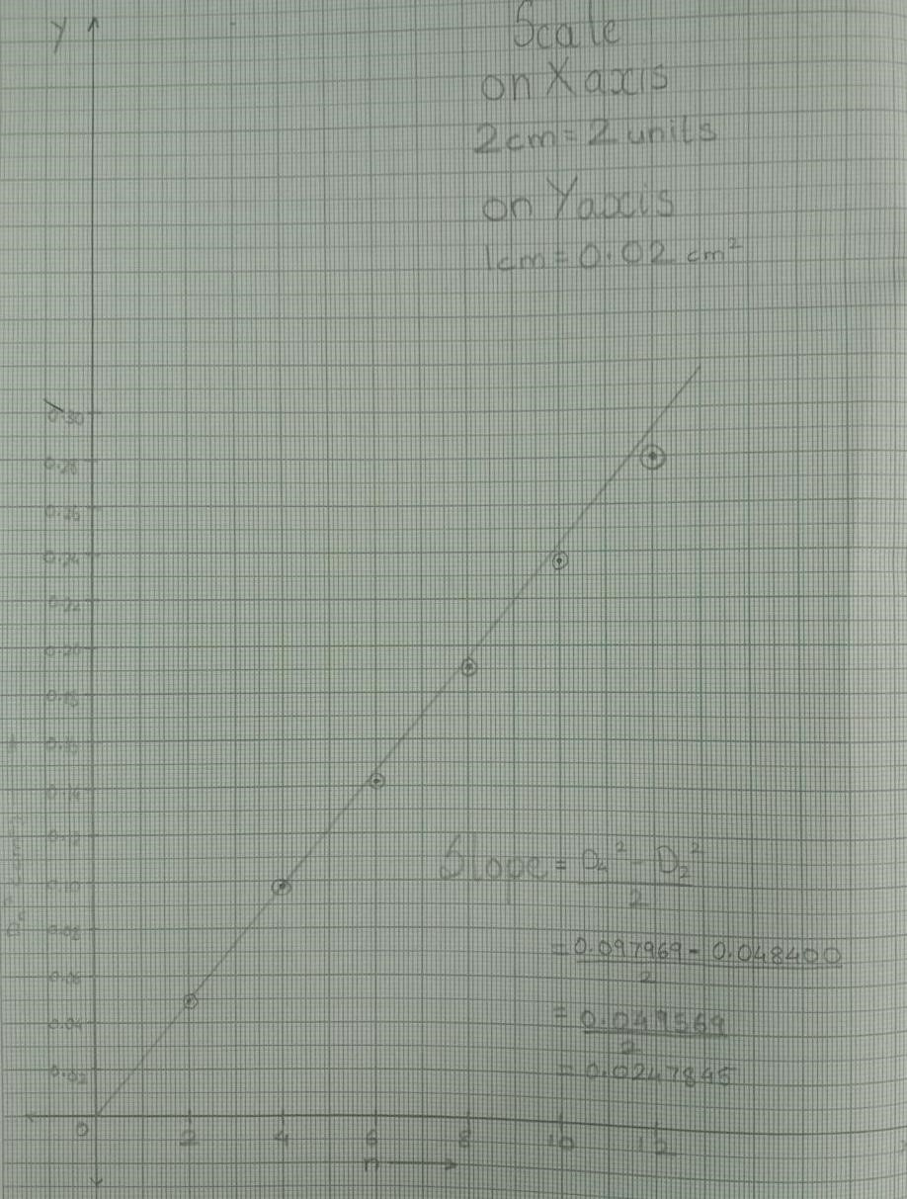

**Calculations:**

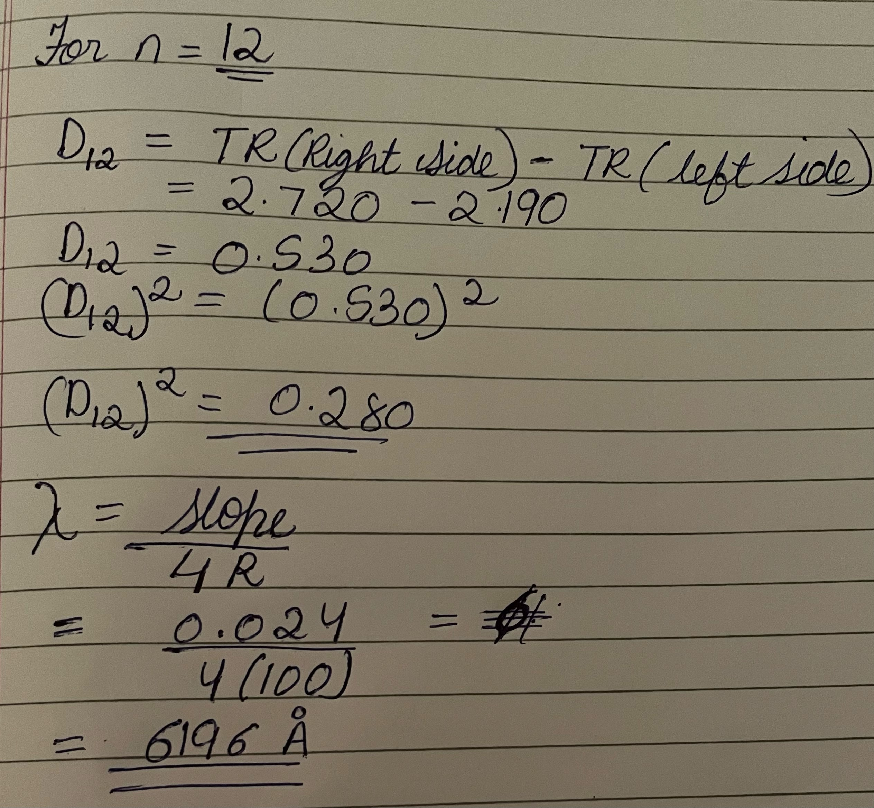

**Results:** The wavelength of sodium light source in air medium is approximately 6196 Å